Appreciative Inquiry
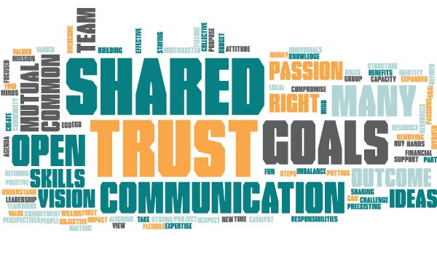
Removing Ego putting outcome first
It’s fun
Understand resource imbalance
Willing to compromise
Aligning sharing resources
No ego
Defining steps
Effective communication
Communication
Passion
Commitment to project by all involved
Having a positive group impact
Buy in
Strong Leadership
Financial support
Local/community
Teamwork
Budget money
Many hands
Expanded capacity
Trust
Trust
Trust
Take time to create trust
Building trust
Multifaceted skills ideas
Communication
Open to new ideas collective knowledge open mind
Many skills and expertise
Many minds
Shared goals
Shared purpose
Shared mission objective agenda goals outcome
Common goals passions
Vision
Can do attitude
Identity and overcome challenge
Find mutual benefits
Shared goals
Staying focused on the goal
Common view
Shared passion vision
Defined roles responsibilities
Having the right people
Value of varied perspectives
Mutual respect
Preexisting structure waiting for a catalyst
Individuals are open flexible
Having the right team
Feeling valued part of a team

